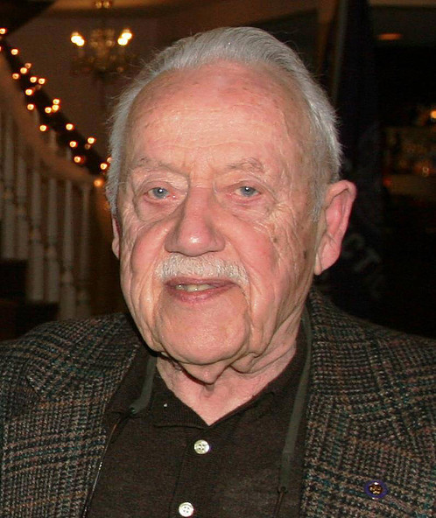

Rodman Truax Kneen was born in Derby in 1923, to Dr. George and Ruth Truax Kneen. Rod’s uncle, Edward Kneen, was the first Mayor of Shelton.

In 1932, Rod joined Cub Scout Pack 3, sponsored by Derby United Methodist Church, just two years after Cub Scouts became an official program of the Boy Scouts of America. In 1932 he also performed in his first Scout Gang Show, called a minstrel show at the time.

In 1935, Rod joined Boy Scout Troop 3 Derby and was a member of the Housatonic Council contingent to attend the first National Scout Jamboree, held in Washington DC, in 1937. In 1939, Rod was a charter member of Senior Troop 33, which became Explorer Post 33 and eventually Venture Crew 33. Also in 1939, Rod served with Troop 3 as a Safety Monitor at the 1939 World’s Fair, held in New York City.

Rod is Troop 3’s 28th Eagle Scout. Rod was a part of a Air Scout Squadron, named for his brother George Kneen, who was an Air Force Colonel piloting combat missions during WWII and the Korean War. Rod himself enlisted in 1943, and served during WWII for 2 years in the Air Corps Reserve.

Upon returning from the war, Rod became Post 33’s Advisor, a position he held for more than 60 years. While Advisor he was coach of the Post 33 basketball team that included Bob Skoronski, who went on to captain the Super bowl Champion Green Bay Packer’s Football Team. Rod attended college at Texas A&M for 2 years and worked as a machinist for 43 years at Farrell’s Birmingham in Derby.

Rod was married for 56 years to the late Ruth Ledger. He is the proud father of Robin Hartel and 1972 Troop 3 Eagle Scout Rodman Kneen Jr. He has 4 grandchildren and 2 great-grandchildren. His grandson Jayson Kneen and his nephew, Eagle Scout and Housatonic Council President James Connery, were also members of Troop 3. Rod was a 50 year member of the Huntington Congregational Church and the Farrell’s Old-timer’s Club.

Rod served Venture Crew 33 as Committee Chairman and for 63 years he was the director of the Stooges performing in the Pack 3, Troop 3 and Crew 33 Scout Gang Show. Rod was one of the many Scouting volunteers responsible in the early development of the Housatonic (now Edmund D. Strang) Scout Reservation.

Rod has been honored numerous times by the Boy Scouts of America for his outstanding service to Scouting. He earned the Housatonic Council President’s Award in 1971 and the Silver Beaver Award in 1972. He was honored with the Spurgeon Award for Exploring in 1973. Rod was presented with a James E. West Fellowship Award in 1999, when he was also honored with the “3 for Life” Award for his service to Troop 3.

It should be no surprise that Rod was honored by the Valley United Way with the “Living Treasure” Award. He surely was a living treasure, with 83 years of service to Scouting, spanning from the beginning of Cub Scouting until his passing in December, 2015.

The Housatonic Council recognizes Rodman Kneen as the Council’s 4th National Outstanding Eagle Scout Award recipient. Would Rodman Kneen Jr. and Robin Hartell please come forward to except their father’s award.

