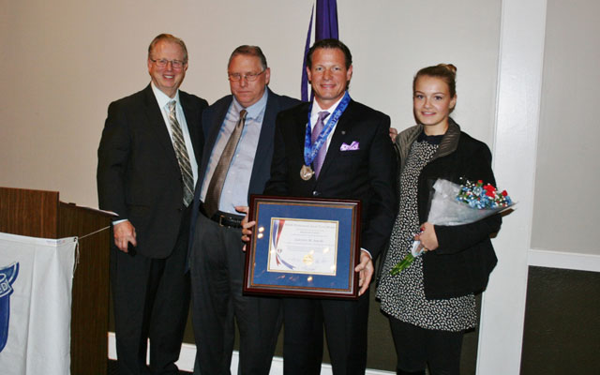

Larry Janesky was born in Bridgeport in 1964 to young parents of modest means. He became involved in Scouting when his older brother joined. When Larry was old enough, he did too. He was very interested in the activities that Scouting presented that he did not have a chance to experience in his urban neighborhood. The skill awards and merit badges exposed him to new practical knowledge he didn’t get in school. And the idea of moving up in rank as you achieved various requirements pulled Larry into the challenge.

He began learning about leadership too. As Patrol Leader in Troop 108 at Beardsley School in Bridgeport, and Assistant Senior Patrol Leader and then Senior Patrol Leader, Larry learned some things that worked, and some things that didn’t. He became an Eagle Scout at age 14 in 1978. For his Eagle Scout project he painted the lighthouse at Seaside Park. He didn’t stop there. He earned 56 merit badges, and five palms, and was active in Order of Arrow Tankiteke 313 where he became a Brotherhood member. He loved working on staff at Camp Aquila on Candlewood Lake for three seasons, where he taught swimming and lifesaving.

Scouting gave him a lot of experience and confidence, and the Scout Law and Oath taught him a love of country, and moral code to live by. After he graduated from Bullard Havens high school in Bridgeport, Larry went right to work putting an ad in the paper “Carpentry, call Larry, no job too small”.

Larry became a carpenter, builder, entrepreneur, author, and trainer. Today he runs eight related businesses that he started over his 33 year career, the largest of which is Basement Systems Inc. Together they are the largest employer in Seymour with 300 employees. Larry has written dozens of books and audio training programs, holds 30 patents, and was inducted into the Connecticut Business Hall of Fame.

Larry has been happily married to his wife Wendy for 22 years, and has three children. They now live in Middlebury Connecticut. He is an expert motocross rider and racer, and rides twice a week on his own track in Newtown.

Please welcome Housatonic Council’s 3rd National Outstanding Eagle Scout Award to Larry Janesky

