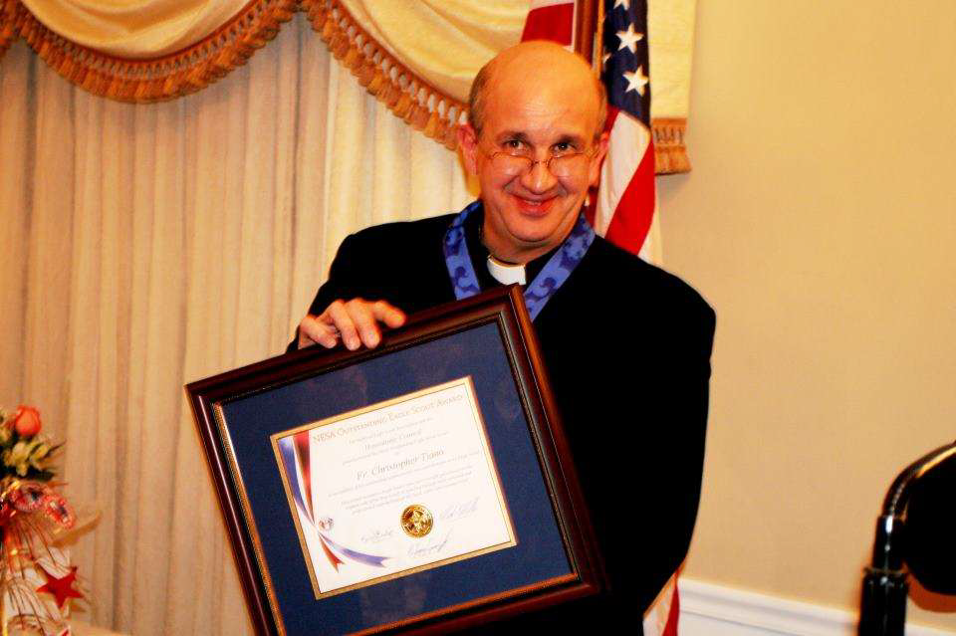

Father Chris Tiano is a Derby native, born on January 18, 1961. He is the son of Elizabeth Tiano and the late Eugene Tiano. He joined Pack 3 in September of 1968 and has been part of the Scouting movement ever since. He is Troop 3’s 168th Eagle Scout and one of his proudest boasts is that our beloved Ed Strang presented his Eagle. He was the senior patrol leader of the Council’s contingent to the 1977 Jamboree.

He is a 1979 graduate of Fairfield Prep. He graduated from Georgetown University in 1983 with a degree in Government. After graduation he worked for a year for the United States Congress, and then entered seminary formation in Boston. He was ordained to the priesthood in 1989, and has served parishes in New Britain, Hartford, West Haven and now Torrington. In 1994 he was sent for further studies to the Gregorian University in Rome. He also served for six years as the editor of The Catholic Transcript, where he was honored by the National Catholic Press association for his articles and editorials.

Since his return to Connecticut, he has been involved in Scouting in a variety of ways. A longtime member of Troop 3’s committee, He has served as chaplain for the summer camp through most of the past twenty years. Additionally, he has assisted Troop Three at summer camp as a unit leader, and accompanied the troop on a trip to Europe. In 1996 he was elected to the Council Executive Board, he has served as a member of the Budget Committee, the Endowment Committee and the Nominating committee. He was on the selection committee for the Scout Executive. He was part of the Long Range Planning Committee. In 2004 he was elected as Council President, as president he balanced the budget two out of the three years, and the council made quality council in 2005.

He is the past recipient of the President's Award, the Silver Beaver, the Bronze Pelican, and the St. George's Medal. Please welcome Housatonic Council’s 1st National Outstanding Eagle recipient, and Troop 3’s 168th Eagle Scout Father Chris Tiano.

