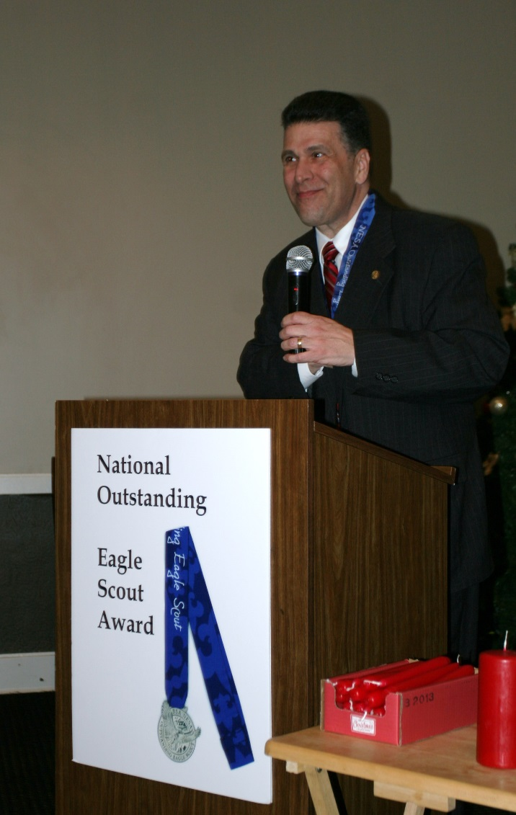

He began his Scouting experience in the former Mattatuck Council, which was based in Waterbury, Connecticut. As a member of Troop 39, he earned the Eagle Scout award in 1977.

He registered as an Assistant Scoutmaster with Troop 1 when his son joined the troop. He supported the troop on frequent campouts and at summer camp. He was invited to serve on the Council Executive Board, and selected to serve as VP of Program. As VP of Program, he gave leadership to the activities, advancement, camping, and training initiatives of the Council, with the primary goal that all members had opportunities for safe and high-quality Scouting programs.

After serving as VP-Program for four years, he was selected to serve as Council President, a position he held for another four years. During his tenure as Council President, Housatonic Council has achieved many noteworthy accomplishments, including achievement of Quality Council in 2008 and Centennial Quality Council in 2010.

In addition, the Council has made significant progress toward the construction of a new shower house at Camp Strang, established a functioning District Committee that supports unit operation while multiplying the efforts of the Executive Board, and laid the groundwork for the development of a new strategic plan.

He has also supported Scouting in the Housatonic Council by being a founding member of the Housatonic Council Eagle Scout Association, and Assistant Scoutmaster at Adventure to Eagle Week at Camp Strang, and a merit badge counselor at Winter Camp.
He also serves Scouting as a member of the Catholic Committee on Scouting for the Archdiocese of Hartford.

He received the Silver Beaver Award, the highest award a Council may bestow on a volunteer, to an outstanding volunteer in 2011.

I would like to present Housatonic Council’s 2nd National Outstanding Eagle Scout Award to my father, Judge Richard Marano, Sr.

